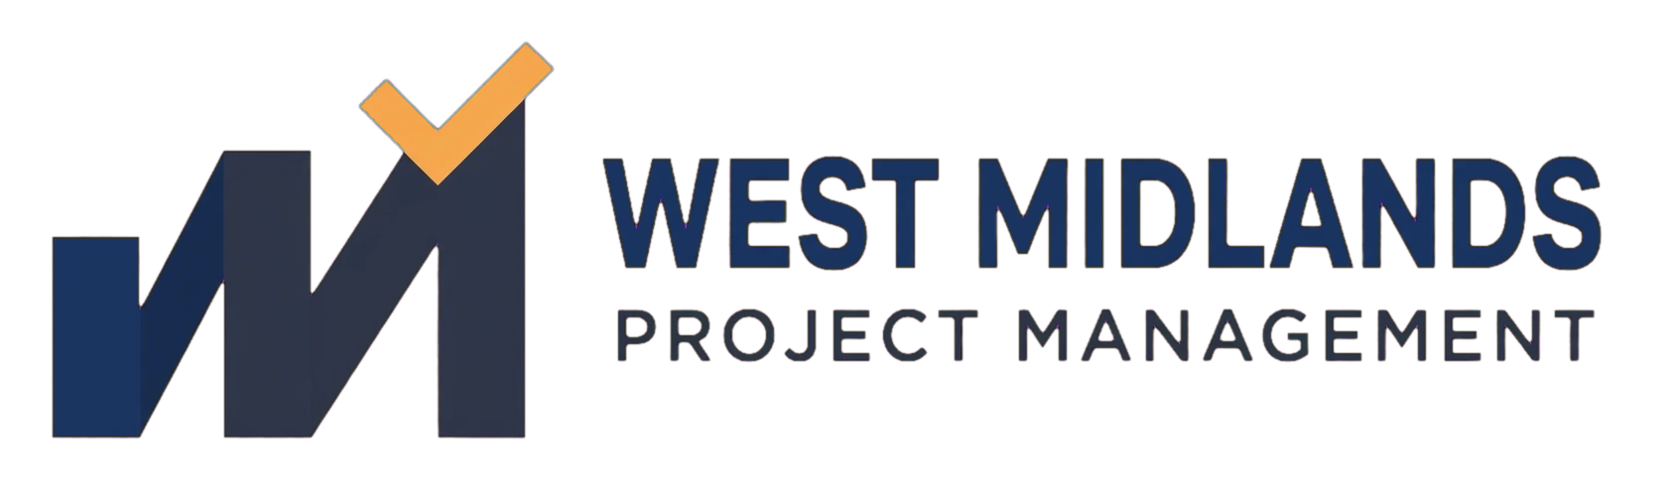

Highlight Report
PRINCE2-Aligned Template

FREE TEMPLATE — provided for reuse with no obligation

This is an original template created by West Midlands Project Management, structured around widely-used PRINCE2 project-management principles. It is not an official AXELOS-published or AXELOS-licensed document, and its use does not imply any AXELOS endorsement or certification.

Document Control
Document Title | [Insert project/programme name] — [this document name]
Version | 0.1 (draft)
Author | [Name, role]
Date | [DD/MM/YYYY]
Status | [Draft / Under Review / Approved]

1. Reporting Period
[Insert reporting period, e.g. 1–14 March 2026]

2. Overall Status
Area | RAG Status | Trend
Time | [Red/Amber/Green] | [Improving/Stable/Worsening]
Cost | [Red/Amber/Green] | [Improving/Stable/Worsening]
Scope | [Red/Amber/Green] | [Improving/Stable/Worsening]
Quality | [Red/Amber/Green] | [Improving/Stable/Worsening]
Benefits | [Red/Amber/Green] | [Improving/Stable/Worsening]

3. This Period's Progress
[Summarise what was completed against the plan this period.]

4. Next Period's Forecast
[What is planned for the next reporting period.]

5. Issues & Risks Requiring Attention
Issue / Risk | Impact | Action Needed | Owner
[Insert] | [Insert] | [Insert] | [Insert]

6. Budget Summary
Budget | Spent to Date | Forecast at Completion
[Insert] | [Insert] | [Insert]

7. Decisions / Actions Required from the Project Board
[Anything the board needs to decide or action this period.]

